Red Hot Pokers
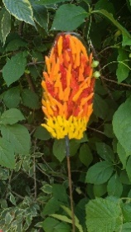
Individually pieces of orange and yellow glass to create a red-hot poker style flower placed on a metre high steel rod. Can be transparent or opaque glass.
Approx. 150cm tall

Blue Delphiniums
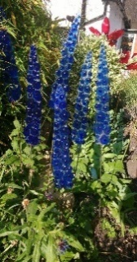
Light, medium or dark blue individually pieces of glass to create a delphinium style flower, placed on metre high steel rod
Approx 150cm tall

Foxgloves
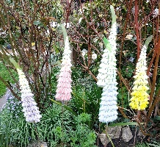
Variety of colours with black dot detail, individual pieces of glass placed on a background, on a metre-high steel rod
Approx 150cm tall

White Daisy with yellow centre
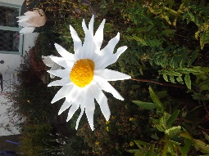
Individually created white opaque petals with a yellow magnetic centre
Approx 150cm x 30cm
Variety of colours

Yellow Sunflower with black centre
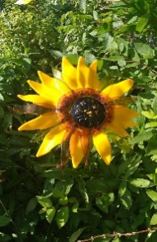
Bright yellow opaque glass sunflower with black textured and magnetic centre
Approx 180cm x 40cm

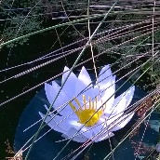
Water lily
White opaque glass creating delicate waterlily that floats on a glass pad. A weight keeps the lily in place without crashing into the pond sides
Approx. 30cm wide
Variety of colours

Glass Panels
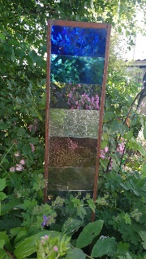
Placed between a metal frame, which can be left natural to rust or coloured black. The glass colours can vary according to taste and style. Panels can have fused panel incorporated for the personal touch.
Approx 100cm x 18cm
Variety of Colours

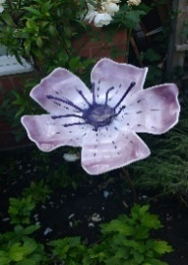
Corn cockle
Individually created open style petals with purple and black detail. Magnetic centre
Approx. 150cm x 30cm
Variety of colours

Red Poppy
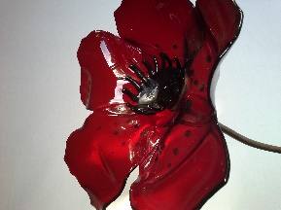
Individually created medium red poppy with black dot detail. Black magnetic centre
Approx. 150cm x 30cm

Buttercup
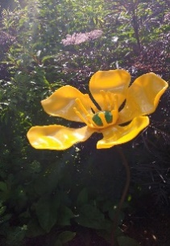
Individually created rounded petals in buttercup yellow, yellow stamen and green magnetic centre
Approx. 150cm x 30cm

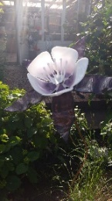
Columbine
Individually created petals in white and pale purple, with a magnetic centre.
Approx. 150cm x 30cm
Variety of colours

Pansy
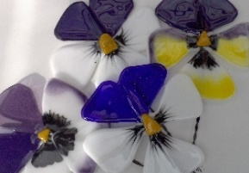
Individually created petals fused onto small metal stick
Approx 25cm tall
Variety of colours

Fishes
Individual fishes can be different colours, placed on a steel metre high rod.

Birds
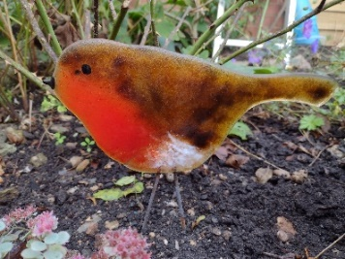
Individual birds can do variety: Blue Tits, Robins, Blackbirds, Doves, Woodpeckers. Wrens, Kingfishers, please just ask
Approx. 26cms x 13cms
Variety Birds

Spiders Web
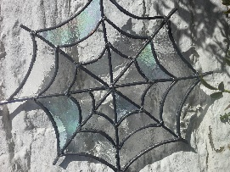
Stained glass spiders web consisting of lead and textured glass, can be assorted colours

Approx 30cm width & height
Variety of colours

Cosmos
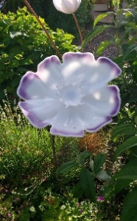
Individually created petals in white and pale purple around the edge, with a magnetic centre.

Approx. 150cm x 30cm
Variety of colours

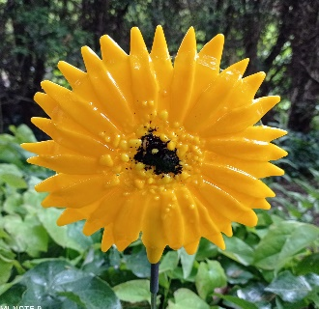
Gerbera Flowers – Various Colours
Approx. 130cm x 25cm
Variety of colours

Stargazer Lily
Individually created petals in white decorated with orangy/red, with a magnetic centre.
Approx. 150 x30
Colour will vary

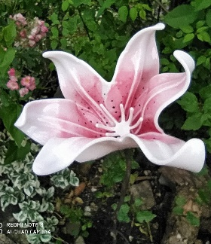

Orange lily
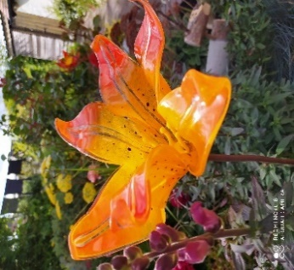
Individually created petals in white and pale pink with small black dots in centre, with a magnetic centre
Approx. 150 x 30cm
Colour will vary

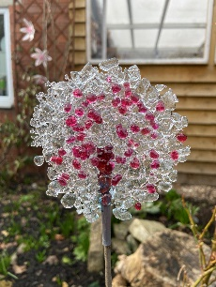
Alliums
Individually created circles of glass double sided in pinks, white or blues
Approx. 3” Circumference
Colour will vary.

Garden Art:
Butterfly
Owl
Flames
Leaves

More complex flower displays: one off pieces of work

Clematis
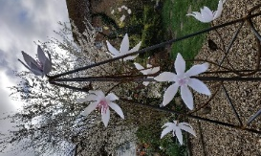
This piece comes already made with the obelisk frame. There are individual clematis with magnetic centres. Colours for the clematis can be chosen to suit your garden
Price on application

Lily of the valley,
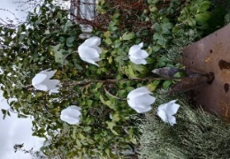
Individually made flowers and centres on a steel stand

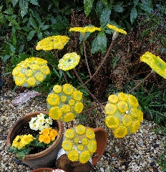
Tansy/Smaller Cow Parsley/Daisy/ Forgetmeknot
Stands approx. 3ft tall without the wooden block
individually cut petals placed on a circle of glass with

Large Cow Parsley - Price on application
Rambling Rose - Price on application

I am always trying to come up with new
flowers that I can develop so welcome new ideas.

General Information
All the flowers can be customized to a colour of your choice, please contact me to discuss. All sizes are approximate due to being individually handmade.
They come complete with a metal stand to which they are attached The centre is detachable, that again can be a colour of your choice.
When placing your flower make sure that the metal Pipe goes well into the ground to keep the flower secure.
The flowers can be kept outside all year to provide colour even when your garden has died back in the winter. We recommend that you bring them in if the weather is extreme, for example heavy snow, high winds and extreme frost.
Please do not leave the water lily in the pond in the winter if the water freezes
To clean the flowers, gently remove the magnetic centre and wash with warm water and soap.
To appreciate the flowers true colours please come and visit our studio and garden where they are on display all year.
Flowers can be posted but there will be postal charges

Please phone before visiting Mobile : 07877 415017

The Art Pad
Brochure 2024
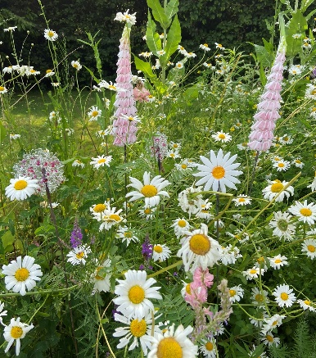

The Old Place, Main Street
Offenham, Worcestershire
WR11 8RX
Tel: 07877 415 017

Email: wendy@theartpad.co.uk

